Practicum Case | 
MATH6183 | MATH6183001 | MATH6183016 | MATH6183049
Scientific Computing
Mathematics & Statistics | E231-MATH6183-JJ01-04
Valid on Even Semester Year 2023/2024 | Revision 00

Learning Outcomes
- LO3 – evaluate the application of taylor series and root of equations in scientific computation

Topic
- Session 04 – Root of Equations

Sub Topics
- Newton-Raphson Method
- Bisection Method

Soal
Case

- Newton Raphson
Find the root of the equation from the equation f(x) below by using Newton Raphson method:
$$f\left(x\right) : x^{6}+2x^{2}-3$$

- How many iterations are required to find the root of the equation?
- With first guess of the value is 4.
- With tolerate error is 0.01.
- With the number of the max iterations is 15.
- Print the result of the root in each iteration. If the iteration is over the max iterations the print error message.
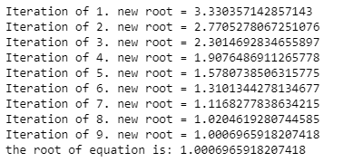
Figure 1. Newton Raphson Result with Tolerate Error 0.01
- Bisection
Find the root of the equation from the equation f(x) below by using Bisection method:
$$f\left(x\right) : 10x^{3}+8x^{2}+9$$
With the following coordinates x1 and x2 are:
- x1 = 3, x2 = 4
- x1 = -10, x2 = 17
- x1 = 10, x2 = -15
- x1 = -2, x2 = 4
- x1 = 12, x2 = -5
- x1 = -8, x2 = -13
- x1 = 7, x2 = -21
coordinates = [
[3, 4],
[-10, 17],
[10, -15],
[-2, 4],
[12, -5],
[-8, -13],
[7, -21],
]
- Find the root of each coordinate.
- Print the result of the root in each iteration of coordinates.
- With tolerate error is 0.001.
- For each iteration of coordinates, validate coordinate x1 and x2 must not be the same sign.
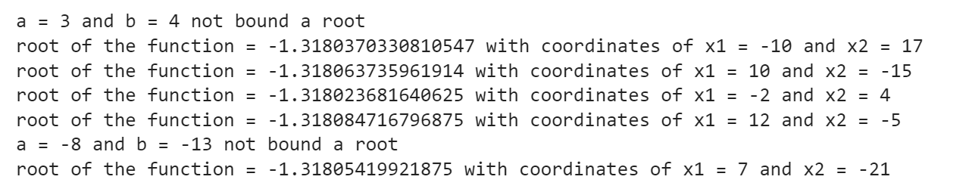
Figure 2. Root of the Equation of Each Coordinate with Bisection

